# Amazon Route 53 Failover Routing

## The architecture diagram shows the final state of the infrastructure that I build. Route 53 records store the IP address of the EC2 instance in each Availability Zone. User requests are normally sent to the IP address corresponding to Café Instance1 in Availability Zone 1. If Café Instance1 is unavailable, requests are routed to Café Instance2 in Availability Zone 2 based on the configuration in the Route 53 record

## 

## Task 1: Confirming the café websites

In this task, you analyze the resources that AWS CloudFormation has automatically created for you.Copy the values for PUBLICLY AVAILBLE WEBSITE the following parameters, and paste them into a text editor to use later.

CafeInstance1IPAddress 50.112.247.40

PrimaryWebSiteURL 50.112.247.40/cafe

SecondaryWebsiteURL 34.214.240.61/cafe

CafeInstance2IPAddress 34.214.240.61

* **AWS Management Console**. In the **Search** bar, enter and choose EC2 to open the **EC2 Management Console**.
* In the left navigation pane, in the **Instances** section, choose **Instances**. Two EC2 instances exist. **CafeInstance1** is running in Cafe Public Subnet 1 (us-west-2a), and **CafeInstance2** is running in Cafe Public Subnet 2 (us-west-2b).
* Paste the value for **SecondaryWebsiteURL**. Choose any item on the menu, and choose **Submit Order.** The **Order Confirmation** page reflects the time that the order was placed in the time zone where the web server is running.

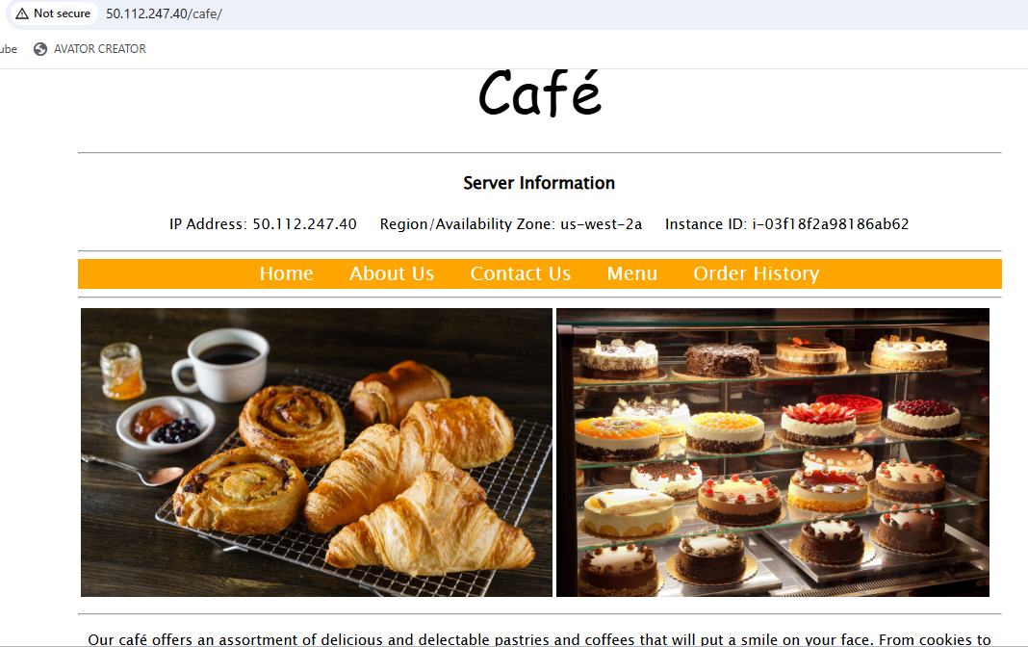

## Task 2: Configuring a Route 53 health check

The first step to configure failover is to create a health check for your primary website.

1. Choose **Create health check**, and configure the following options. Leave the default values for all other fields.
   * **Name:** Enter Primary-Website-Health
   * **What to monitor:** Choose **Endpoint**.
   * **Specify endpoint by:** Choose **IP address**.
   * **IP address:** Paste in the **Public IPv4 address** of **CafeInstance1**. You can find this value in the EC2 console, or you can copy the IP address from the **CafeInstance1IPAddress** value that you copied earlier.
   * **Path:** Enter cafe

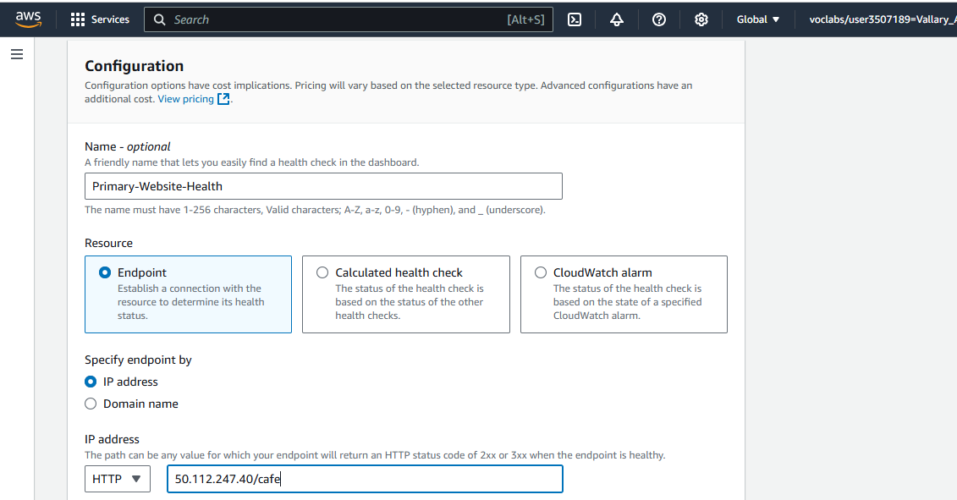

1. For **Get notified when health check fails**, configure the following options:
   * **Create alarm:** Choose **Yes**.
   * **Send notification to:** Choose **New SNS topic**.
   * **Topic name:** Enter Primary-Website-Health
   * **Recipient email address:** Enter an email address that you can access.

**Task 3: Configuring Route 53 records**

In the following tasks, you create Route 53 records for the hosted zone.

**Task 3.1: Creating an A record for the primary website**

Configure failover routing based on the health check that you just created.

1. Choose **Create record**, and configure the following options:
   * **Record name:** Enter www
   * **Record type:** Choose **A - Routes traffic to an IPv4 address and some AWS resources**.
   * **Value:** In the text box, enter the IP address for **CafeInstance1IPAddress**.
   * **TTL (seconds):** Enter 15
   * **Routing policy**: Choose **Failover**.
   * **Failover record type:** Choose **Primary**.
   * **Health check ID:** Choose **Primary-Website-Health**.
   * **Record ID:** Enter FailoverPrimary
2. Choose **Create records**.

The A-type record that you created should now appear as the third record on the **Hosted zones** page.

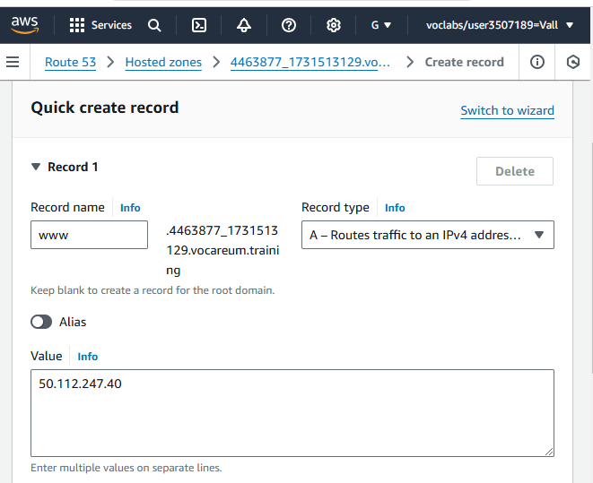

### Task 3.2: Creating an A record for the secondary website

Now you create another record for the stand-by/secondary web server.

1. Choose **Create record**, and configure the following options:
   * **Record name:** Enter www
   * **Record type:** Choose **A - Routes traffic to an IPv4 address and some AWS resources**.
   * **Value:** In the text box, enter the IP address for **CafeInstance2IPAddress**. To find this value, at the top of these instructions, choose **Details**, and then choose **Show**, or copy it from the values that you pasted into a text editor earlier in the lab.
   * **TTL (seconds):** Enter 15
   * **Routing policy**: Choose **Failover**.
   * **Failover record type:** Choose **Secondary**.
   * **Health check ID:** Leave this field empty.
   * **Record ID:** Enter FailoverSecondary
2. Choose **Create records**.

Another A-type record should now be listed on the **Hosted zones** page.

You have now configured your web application to fail over to another Availability Zone.

## Task 4: Verifying the DNS resolution

In this task, you visit the DNS records in a browser to verify that Route 53 is pointing correctly to your primary website.

1. Select the check box for either one of the A records. A **Record details** panel appears that includes the **Record name**. Copy the **Record name** value of the A record.

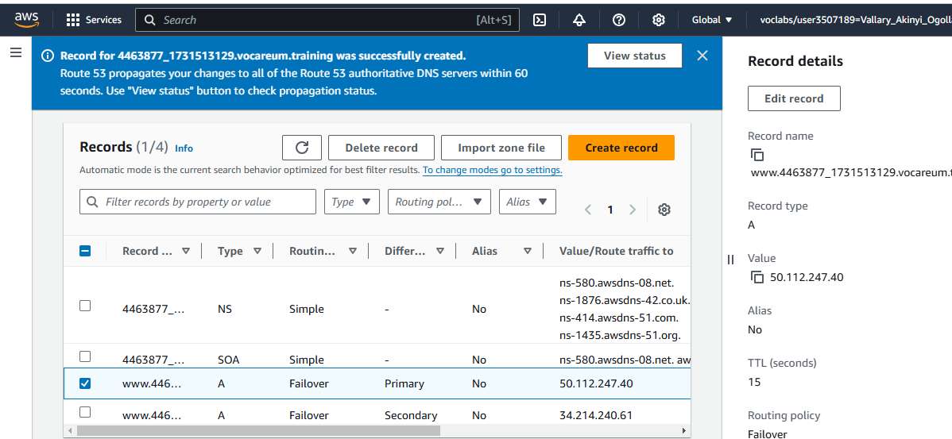

Open a new browser tab. Paste the A record name, enter /cafe at the end of the URL, and then load the page.

The café primary website should load, as indicated by the **Server Information** section of the page, which should display the **Region/Availability Zone**.

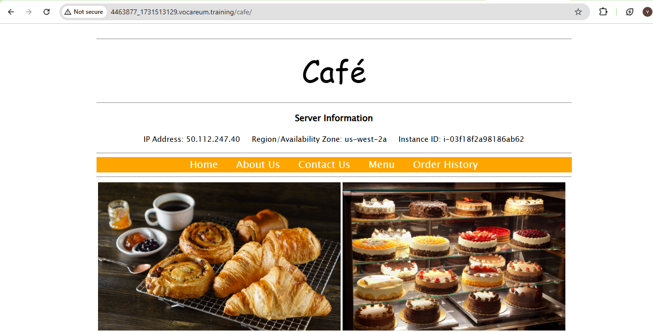

## Task 5: Verifying the failover functionality

In this task, you try to verify that Route 53 correctly fails over to your secondary server if your primary server fails. For the purposes of this activity, you simulate a failure by manually stopping **CafeInstance1**.

1. Return to the AWS Management Console. On the **Services** menu, enter and choose EC2 and then choose **Instances**.
2. Select **CafeInstance1**.
3. From the **Instance state** menu, choose **Stop instance**.
4. In the **Stop instance?** window, choose **Stop**.

The primary website now stops functioning. The Route 53 health check that you configured notices that the application is not responding, and the record entries that you configured cause DNS traffic to fail over to the secondary EC2 instance.

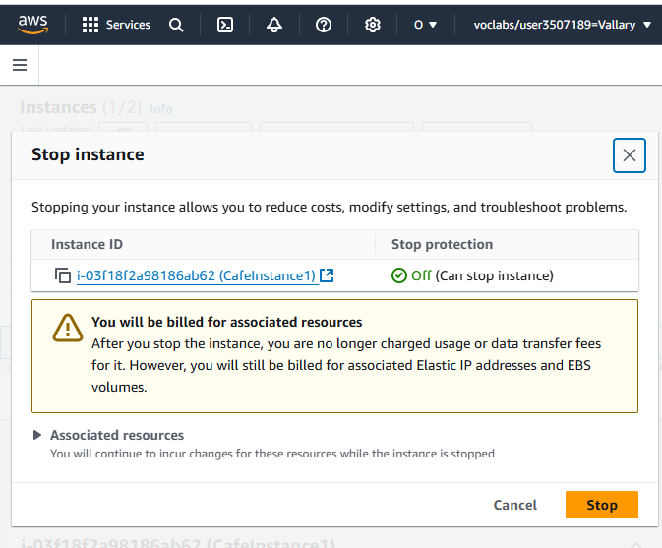

1. On the **Services** menu, enter and choose Route 53
2. In the left navigation pane, choose **Health checks**.
3. Select **Primary-Website-Health**, and in the lower pane, choose the **Monitoring** tab.

You should see failed health checks within minutes of stopping the EC2 instance.

1. Wait until the **Status** of **Primary-Website-Health** is Unhealthy. If necessary, periodically choose refresh. It might take a few minutes for the status to update.
2. Return to the browser tab where you

